**Asiqul Hoque**

**Section 6 Lesson 1:Fundamentals of Subqueries**

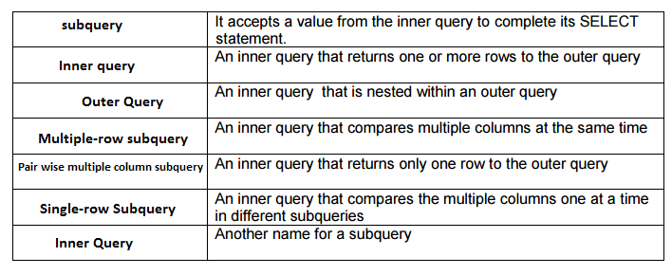

**1.Subqueries enable us to find information we need so that we can get the information we want.**

**2. A subquery is a SELECT statement that is embedded in a clause of another SELECT statement.**

**3. SELECT event_id**

**FROM d_play_list_items**

**WHERE event_id=(select event_id from d_play_list_items WHERE song_id=45);**

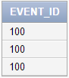

**4. SELECT name**

**FROM d_events**

**WHERE cost>(select cost from d_events where id=100);**



**5. SELECT cd_number**

**from d_track_listings**

**WHERE song_id=(SELECT song_id FROM d_cds WHERE title='Party Music for All Occasions');**

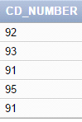

**6. SELECT name**

**FROM d_events**

**WHERE theme_code=(SELECT code FROM d_themes where description='Tropical');**

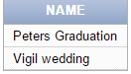

**7. SELECT last_name,first name**

**FROM f_staffs**

**WHERE salary>(select salary from f_staffs where id=12);**

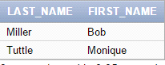

**8. SELECT last_name,first_name**

**from f_staffs**

**where staff_type!=(select staff_type from f_staffs where last_name='Miller' and first_name='Bob');**

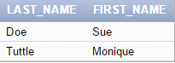

**9. SELECT last_name,first_name**

**FROM employees**

**WHERE department_id=(select department_id from departments where department_name='IT');**

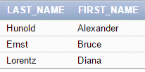

**10. SELECT department_id**

**FROM departments**

**WHERE location_id=(select location_id from locations where city= 'Seattle');**

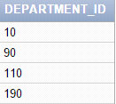

**11.**

**True**

**False**

**True**

**12. SELECT last_name,first_name,department_id, manager_id**

**FROM employees**

**WHERE (manager_id,department_id) IN (select manager_id,department_id FROM employees WHERE employee_id IN (141));**

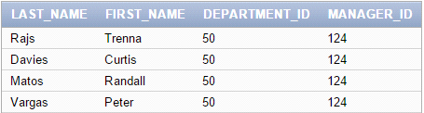

**13. SELECT last_name,first_name,manager_id,department_id**

**FROM employees**

**WHERE manager_id IN (Select manager_id**

**from employees**

**where employee_id IN (141))**

**AND department_id IN (select department_id**

**from employees**

**where employee_id IN (141));**

